SO(3). For this manifold being not Euclidean, the classical approach consists in linearising the nonlinear attitude dynamics around some condition (usually the hovering flight condition for quadcopters), and designing controllers based on a set of Euler angles to represent orientation [20, 31]. In addition to this strategy not allowing to perform agile and aggressive manoeuvres, **Euler** angles suffer from ambiguities in representing attitude and are kinematically singular. In the modern literature unit quaternions are frequently adopted as a mean of parameterising rotation matrices [32, 33]. **Quaternions** are vectors which lie on the three dimensional unit sphere S 3 and provide a global representation of the attitude of a rigid-body. However, the map from S 3 to SO(3) is not unique, as there is always a pair of unit quaternions which correspond to the same physical attitude. Neglecting this issue may give rise to undesired phenomena such as unwinding, where the rigid-body rotates unnecessarily through a full rotation [34, 35].

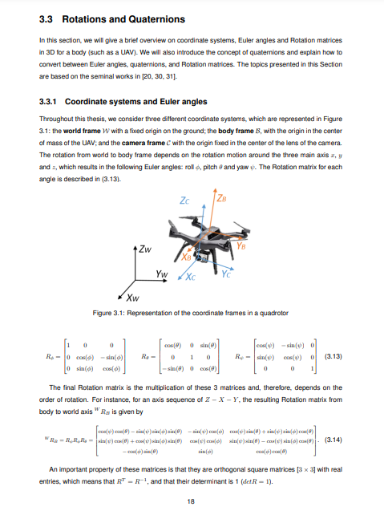

When describing the state of the system, it is necessary to include some components that describe the rotation of the body, which can have three possible representations:

• Euler Angles (φ, θ and ψ) - these may cause problems due to the discontinuities of the angles (− π 2 < φ < π 2 , − π 2 < θ < π 2 and −π < ψ < π), but have the advantage of requiring less storage memory;

• Quaternions (qw, qx, qy and qz) - these may not have issues with singularities, but have the ambiguity that two different quaternions result in the same Rotation matrix. They also require more storage memory than Euler angles and can lead to more complex mathematical manipulations. Nevertheless, they are still faster and more compact than Rotation matrices;

• Rotation matrices - these may be simpler to manipulate and do not have issues with singularities or ambiguities. However, storing a full matrix in a state space may be inefficient. In the end, the method chosen should take into consideration which characteristics, such as timing constraints, memory management, mathematical manipulation, etc., are more relevant for the problem at hand.